ASSIGNMENT No: 8
NAME: Abhyuday Tripathi
PRN: 25070122013
BATCH: A1
TITLE: Write a Java program to demonstrate the use of the super keyword in inheritance.
Problem Statement: Write a Java program to demonstrate the use of the super keyword in inheritance.
Learning Objectives: To demonstrate the use of the super keyword for accessing parent class members.
Theory:
The super keyword is used to refer to the immediate parent class in Java. It can invoke parent class constructors, access parent class variables, and call overridden methods. Super helps distinguish between parent and child class members with the same name. It ensures proper constructor chaining during object creation. It is an important concept in inheritance and method overriding.
Exercise:
1.Create an Employee and Manager program where Manager accesses Employee details using super keyword.
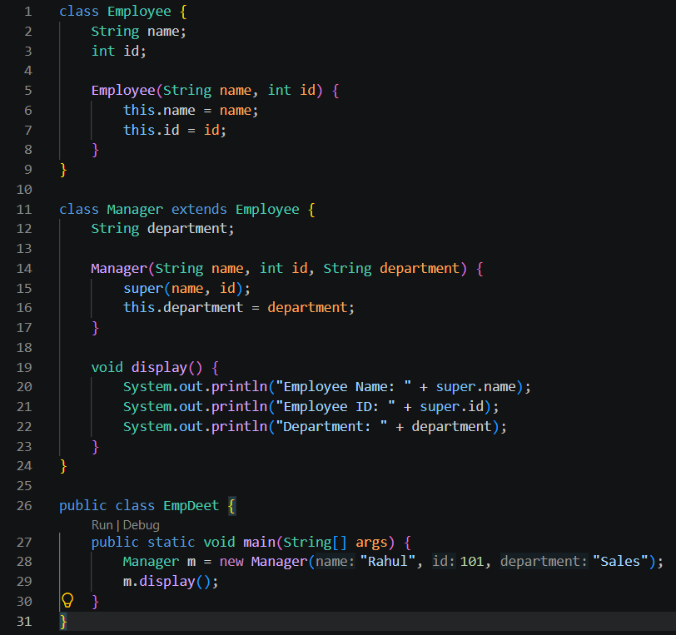
OUTPUT:
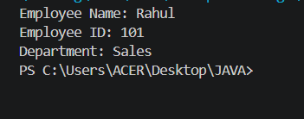

2. Develop a Vehicle Insurance System where child insurance classes access parent vehicle information using the super keyword.
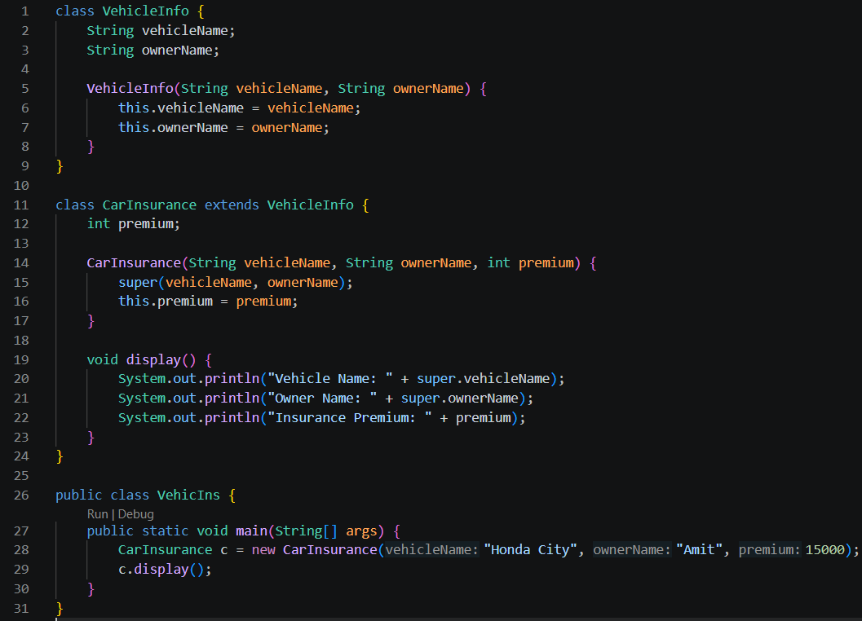
OUTPUT:
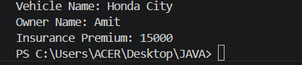
CONCLUSION:
In this experiment, we implemented the concept of super keyword through two classes Employee and Manager, VehicleInfo and CarInsurance. This concept is a part of inheritance which is implemented through the keyword extends.

